Zambia info service SMS content update
Check the content for first 4 service -3 message and last -1 message
step 1: Delete F column
Step2 : select all ,find and replace ' with null
Step 3: copy and paste the update column query from the template
Step 4 : copy f column into .132 server Zambia folder smscontentupdate
Step 5 find and replace " with null
Step 6: find and replace the special charatcer
–
- :
Step 7: align all the update query into single line
Step 8 : connect the AWS server
Step 9: connect the mysql
mysql -umb -p'mobibattle!23' -hmobibattle.clgcbjwtmtg2.ap-south-1.rds.amazonaws.com
Step 10 : use global
Step 11 : exit mysql

Step 12: hit the below curl in the server

curl -iv "http://41.1.2.7:9091/ContentServiceWrapper/reloadContentMap"

Step 13
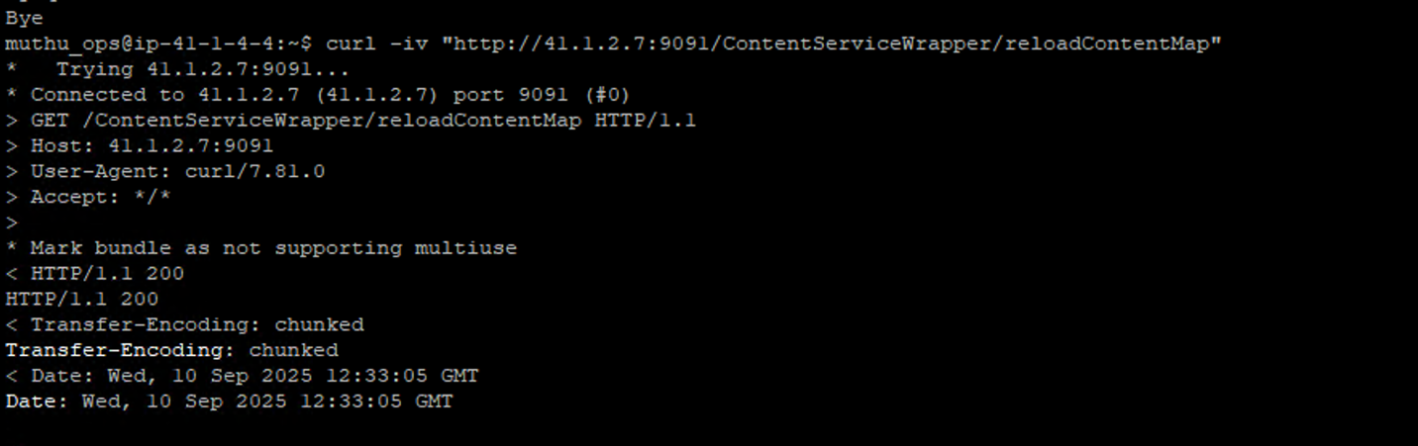

/home/sshmobi/crontab/backup/sysscripts/

